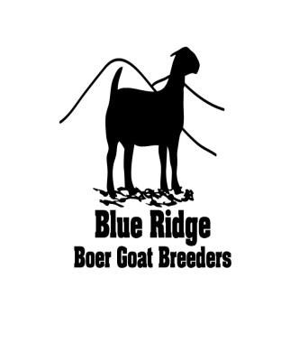
The SUMMER JAM JACKPOT SHOW
JULY 22, 2018
Rockingham County Fair Grounds, Harrisonburg, Va.

Brought to you by:
Blueridgeboergoatbreeders.com

- Youth ages 4 to 21 (at time of show) are eligible to show.
- The entry fee is $15.00 per animal with $5.00 pen fee. You can show off trailer.
- Showmanship classes will be divided in four age divisions: 4-8 Pee-wee, 9-12 Junior, 13-15 Intermediate, 16-21 Senior.
- All meat goat breeds and crosses are eligible to show.
- Exhibitors may show up to three (3) animals in Market Classes.
- Market goats will be divided into classes according to weight.
- All goats must meet USDA scrapie regulations. Those animals that do not will have to leave the show grounds.
- All out of state animals will need health papers within 30 days prior to the show.
- Market goats may be either does or wethers not over one year in age and must be slick shown. No Bucks’. All wethers should be castrated and healed
- Bracing method is up to the discretion of the Judge
- All rules are subject to change by the show committee.
- You must bring a chain to lock your pens. Pens are 5x5.
- The Blue Ridge Boer Goat Breeders, Rockingham Fair Grounds and sponsors will not be responsible for injuries or damage to animals, equipment or persons in connection with the show.
- ABSOLUTELY NO ICING OF ANIMALS OF ANY FORM!! ANYONE IN VIOLATION OF THIS RULE WILL RESULT IN DISQUALIFICATION AND EXPULSION OF THE SHOW.
- The early entry deadline is July 7, 2018 for a reduced entry fee.
- Premiums: Grand Champion $500
Reserve Champion $250
Showmanship: Cash prizes to be determined by number of participants
- Show Date & Times
Sunday July 22, 2018
6:00 AM check in begins
7:30 AM Check in closes
6:30 – 7:45 weigh in
8:00 AM ABGA Sanctioned Show
12:00 PM Goat Showmanship & Market classes (or 30 minutes after Open Show is finished)

***THERE WILL BE A SILENT AUCTION SATURDAY TO HELP RAISE MONEY FOR THE JACKPOT SHOW. IT WILL END AT 6PM. IF YOU WOULD LIKE TO DONATE SOMETHING TO HELP RAISE MONEY, CONTACT DONNA AREY KNOW 540-849-5330** SPONSOR FORMS AlSO ON WEBSITE.
2018 Blue Ridge Boer Goat Breeders Jackpot Youth Show
Exhibitors Name: ___________________________________________________
Age as of 1/1/2018: _________________________________________________ Farm Name: _______________________________________________________
Address: __________________________________________________________
City, State, Zip: _____________________________________________________
Phone: ___________________________________________________________
E-Mail:___________________________________________________________

Sunday July 22, 2018
Name of Animal | Date of Birth | Scrapie Tag Number

Entry Fees if postmarked by July 7, 2018
Total # Goats Entered | Entry Fee | Total
 | $15.00 per head
# pens needed, can show off trailer | Pen Fees, if needed | Total
 | $5.00

Entry Fees if postmarked after July 8, 2018
Total # Goats Entered | Entry Fee | Total
 | $20.00 per head
# pens needed | Pen Fees, if needed | Total
 | $5.00

Pre-order shavings $5.00 a bag | Number bags | Total

Total Enclosed
Send entry form and check made payable to: BRBGB
c/o Stephanie Gorman
15095 Little Dry River Rd.
Fulks Run, Virginia 22830
Call Lance and Donna Arey at 540-849-5330 for questions or contact us via Blueridgeboergoatbreeders.com or find us on Facebook.

